Implemented Neural Network Agent

Predicting the Direction of the Tesla Stock Price

Derek Osik
AI 681 Machine Learning & Pattern Recognition
Abstract:
Forecasting the stock market is very difficult. The financial industry has been attempting to do so for decades. There are far too many indicators for the prediction process to be simple and highly accurate. For the paper I chose, “Hybrid Machine Learning Technique for Forecasting Dhaka Stock Market Timing Decisions'' by Shipra Banik, A F M Khodadad Khan, and Mohammad Anwer., there were five technical indicators relied on. These indicators were the five-day moving average, the twelve-day moving average, the price rate of change, the relative strength index, and the moving average convergence/divergence. This paper also focused on the author’s creation of an artificial neural network rough set hybrid model (ANN_RS) to predict the direction of stock price movement on the Dhaka Stock Exchange. A better use of my brain power and the predictive abilities of a neural network was to create and implement an artificial neural network to predict the direction of the Tesla (TSLA) stock price and establish and act on a strategy based on these predictions. The strategy returns were then mapped against the returns of the market from January 1st, 2020 to December 11th, 2020. Although the rough set (RS) model used by Banik, Khan, and Anwer can extract rules for stock prediction, the coding was beyond my knowledge. However, I took the neural network a step further than the neural network they used by predicting the direction of a stock price, creating a strategy based on those predictions, and mapping the returns of that strategy. Below you will find a description of artificial neural networks (ANN) and their predictive capabilities in the financial industry. This includes a description of my agent compared to Banik, Khan, and Anwer’s as well as the results of my agent’s implementation. Future works are detailed to conclude the paper.

ANN Model:
An artificial neural network (ANN) is vaguely inspired by biological human and animal brains. The system is based on a collection of connected units or nodes called artificial neurons, which loosely model the neurons of a biological brain. Each connection between nodes can transmit a signal to other nodes which then process that signal and can pass the signal along or pass along appropriate response signals. The output of each node is computed by some non-linear function of the sum of its inputs. The connections between nodes are called edges. ANN models, the nodes and edges have weights that are adjusted in training. The ANN in this model is no different than the typical ANN. The ANN receives inputs, assigns appropriate weight coefficients of inputs, calculates weighted sums of inputs, compares this sum with a threshold, and finally determines an appropriate output value. The ANN in this paper has one input layer, two hidden layers, and one output layer, making it a very basic ANN and thus easily replicable. The net input is passed through an activation function, usually the rectified linear unit activation function. The ANN model by Banik, Anwer, and Khan used the sigmoid activation function, which I used for my output layer but not my inputs. Neural networks are trained so that a particular input leads to a particular target output. The training algorithm that the ANN model Banik, Khan, and Anwer created undergoes is the Levenberg Marquardt back-propagation (BP). The BP uses gradient descent (GD) technique to minimize error within the training data. The gradient descent technique tweaks its parameters iteratively to minimize a function to its local min. This technique is most appropriate when the parameters of the model can not be calculated analytically and must be searched for by an optimization algorithm. The exact inputs in this ANN model are index_{t}; index_{t-1} (I = 1,2,3…p, p is AR order) MA5, MA12, PROC, RSI, and MACD. The exact output is index_{t+1}. My ANN undergoes the standard black propagation and the “Adam” optimizer. The inputs are calculated from the open, high, low, close, volume data of the TSLA stock. These inputs are high price minus low price, close price minus open price, the three-day moving average, the ten-day moving average, the thirty-day moving average, the five-day standard deviation, the relative strength index, and the Williams %R. There are more inputs in my ANN, but the same hidden layer structure. In my ANN there are 128 nodes, the weights are initialized from a uniform distribution, there are the same amount of inputs to hidden layers as there are columns in the dataset, and there are two hidden layers.
While the model undergoes training, actual output is compared to target output and output layer error is calculated. The network undergoes backward pass and adjusts its weights based on the comparison to target outputs until the network output matches the target output. At this point, the ANN model training is complete and ready for testing, which happens with a different dataset than the training.
The output of my ANN is ‘True’ or ‘False’, ‘True’ indicating the stock price will increase and ‘False’ indicating the stock price will decrease. The implemented agent then acts on the predictions and generates a strategy that either holds a long position on the stock if the ANN output is ‘True’ or holds a short position on the stock if the ANN output is ‘False’.

Results:
The results of the implemented neural network were inconsistent. Research shows that neural networks operate most accurately when the amount of data points is about ten times the amount of degrees of freedom (parameters) of the market. This was not the case for my data and model as there were less than 250 data points and various parameters. The results of the strategy returns plotted against the market returns from the given time period are shown below.
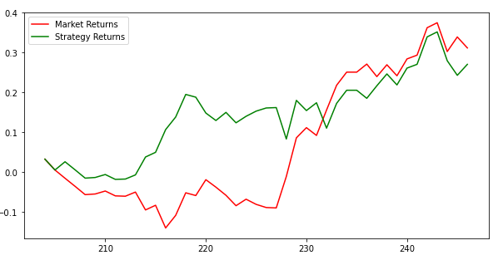
Future Works:
The model strategy returns were very inconsistent. When the model performed its best, it did not significantly outperform the market, meaning the risk of following the strategy offers little reward. The dataset used was too small and future works should start their adjustments with this issue. Ten years worth of data will likely produce a far more reliable market. Furthermore, the predictiveness and strategy of the model is that the stock price will go up or down. The model does not account for the stock price staying the same. As long as the price is not predicted to decline, the strategy will be to hold a long position. The implications of this in reality are reasonable, but it would be most beneficial if future works could account for predicting no movement either direction in the stock price. Similar to my suggested future works for Banik, Khan, and Anwer, trying various ANN structures and layouts as well as activation functions could result in increased performance. This suggestion is worth exploring further.
MLA Works Cited:
Shipra Banik, A. F. M. Khodadad Khan, Mohammad Anwer, "Hybrid Machine Learning Technique for Forecasting Dhaka Stock Market Timing Decisions", Computational Intelligence and Neuroscience, vol. 2014, Article ID 318524, 6 pages, 2014. https://doi.org/10.1155/2014/318524

Shipra Banik, A. F. M. Khodadad Khan, Mohammad Anwer.

